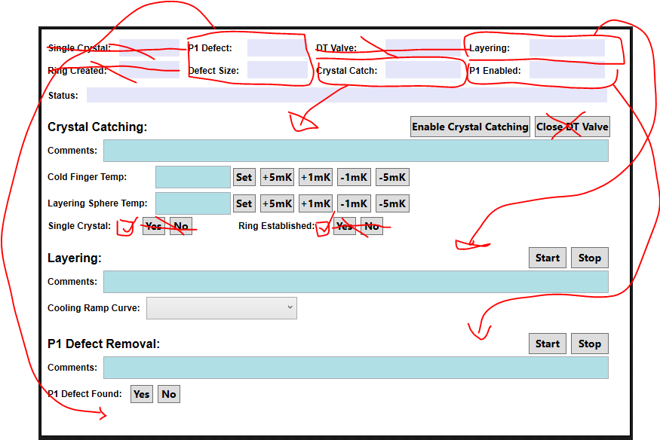

Changes to the GUI:

* Get rid of Single Crystal and Ring Created, these will be indicated by check marks under crystal catching.
* Move P1 Defect and Defect Size to be under P1 Defect Removal.
* Get rid of DT Valve and Valve control button. The MCM will have control over valves at this point.
* Move the Crystal Catch, Layering, and P1 Enabled labels to their corresponding areas.
* Single Crystal and Ring Established will become check boxes.

Questions:

* Should this GUI screen’s buttons and check boxes be completely disabled until after filling completes?
* Should the P1 Defect Found remain a yes/no or be a check box? If a check box is used instead, the P1 Defect indicator label can be removed and just the size label will be needed.
* Will there be times when the user wants to tick up or down the temperature for catching a crystal by something other than 1 or 5 mK? If so, then it may be better to let the user type in the tick size and just have +/- buttons.

Crystal Catching:

* Manual process, the user will control the temperature and check the single crystal and ring established boxes as they achieve these results.

Questions:

* Should Crystal Catching comments be saved when the enable button is pressed or after the crystal is caught and the ring established? If not when enable button is pressed, a button to save the comments to the HDF file needs to be added.
* What does enabling Crystal Catching do and/or allow the user to do that they cannot do until enabled?
* Should Crystal Catching be automatically enabled once filling has completed? If not, should the user be unable to enable it until after filling has completed?

Layering:

* Automated process. The user will select a layering curve from the drop down menu.
* The start button requires that both the single crystal and ring established check boxes are checked.
* Layering curves are stored in the database.
* A layering curve is stored as a series of temperature changes and the time the program will stay at each temperature. Each curve with have a unique CurveID which will be displayed in the drop down menu. Each row will have an order # starting at 1 to identify the order the rows should be executed by the program. The program will set the temperature to the Temperature value in the database, (wait until the temperature is reached?), then stay there for the number of seconds in the Duration (duration is a number in seconds, ie two minutes would be 120).
  + CurveID, Order, Temperature, Duration

Questions:

* Does the timer for staying at a temperature start when the request to change temperature is sent to the Lakeshore or when the temperature is reached?
* Does the temperature ramp apply temperature changes to just the Layering Sphere or also the CFE?

P1 Defect Removal:

* Requires that the layering process completed successfully and the user has indicated that a P1 defect was found.
* Automated process.

Questions:

* How can the program find and determine the size of the P1 defect (what are the characteristics that can be programmatically detected)?
* When are comments saved to the HDF file? When the user indicates the defect is found? When the routine starts? When the routine finishes?
* How is the defect removed?
* How can the program determine that the P1 defect was removed or know to stop the removal process?